
Institute of Information Technology
University of Dhaka

Software Project Lab-2 Final Report
Rental Application

Submitted By
Md Shakibul Islam Shakib Roll: 1404
&
Nandan Bhowmick Roll: 1436

Supervised by: Dr. Rezvi Shahariar Associate Professor IIT,DU

(Supervisor’s signature) Submission Date: 09/03/2025

1

Index

Introduction 5
Purpose 5
Stakeholders 5
Viewpoints 6
QFD(Quality Function Deployment) 6
Normal 6
Expected 6
Exciting 7
User Story 8
User Registration & Login 8
Property Listings 8
View Listings 9
Search by Area 9
Advanced Search Filters 9
Property Details 9
Rent Calculator 9
Property Visit Scheduling 10
Sending Notifications 10
In-Platform Chat 10
Integrated Map 10
Use Case Diagram 11
Level 0 11
Level 1 12
Level 1.1 13
Registration 13
Login 13
Forget Password 14
Level 1.2 14
Landlord Registration 15
Property Management 15
Property Viewing 15
Level 1.2.2 16
Rental History 17
Wishlist 17
Reservation List 17
Landlord's Property List 18
Level 1.3 18
Area-Based Search 18
Advanced Search 19
Level 1.4 19
WishList Notifications 20
Schedule Notifications 20
Activity Diagram 22
Level: 1.1 22
Level: 1.2 23
Level: 1.2.2 23
Level: 1.3 24
Level: 1.4 25
Level: 1.5 25
Level: 1.6 26
Swimlane Diagram 27
Level: 1.1 27
Level: 1.2 28
Level: 1.2.2 29
Level: 1.3 30
Level: 1.4 31
Level: 1.5 32
Level: 1.6 33
Database Modeling 34
Entity Identification 34
Document Schema Diagram 37
Schema Design 38
Class Based Modeling 40
Class Based Modeling Concept 40
Analysis Class Identification 40
List of Verbs in User Story 42
General Classification 44
Selection Criteria 47
Attributes and Method Identification 49
Class Cards 51
CRC Diagram 54
Behavioral Modeling 55
State Transition Diagram 55
List of Events 56
State Transition Diagram 58
Sequence Diagram 68
Data Flow Diagram 69
Level 0 69
Level 1 70
User Manual 71
  - Home Page 71
  - Login Page 74
  - Forgot Password 74
  - Searching 75
  - Viewing Property Details from Listing 76
  - Chat 77
  - Rent Prediction 77
  - Hosting a Property 78
  - User Property Interaction Management 80
  - Notifications 82

Introduction
A house rental app streamlines the rental process by connecting property owners and renters through an intuitive platform. It offers property listings, area-based categorization, real-time chat, secure bookings, and rent prediction to enhance user experience. Renters can easily browse, filter, and book properties, while landlords efficiently manage their listings with minimal effort.
The app ensures that both parties have a hassle-free experience by providing a structured and transparent system for renting properties.
With a focus on convenience, transparency, and trust, the app bridges the gap between renters and property owners, reducing the complexities often associated with finding or listing a rental property. Traditional rental processes involve extensive offline searching, unreliable listings, and communication delays, which this digital solution aims to eliminate. By integrating modern technology and user-friendly features, the app provides a seamless and reliable housing solution, making it easier than ever to find and rent homes.

Motivation
Finding a suitable rental property in Dhaka city can be a daunting task due to high demand, fluctuating rent prices, and a lack of centralized listings. Many renters struggle with limited availability, unreliable brokers, and scattered information, leading to a frustrating experience. Similarly, landlords often face challenges in reaching the right tenants, managing listings, and ensuring secure transactions.
The purpose of this house rental app is to streamline this challenging process, making it more accessible, efficient, and transparent for both renters and property owners. It bridges the gap by offering key features such as detailed property listings, area-based categorization, real-time communication, and secure payment options, ensuring a smooth and reliable rental experience.
For renters, the app simplifies property search by providing clear descriptions, high-quality images, predictive pricing models, and interactive maps to enhance decision-making. The built-in rent predictor helps users understand rental trends and estimate fair pricing based on location and property features. Additionally, direct interactions with landlords eliminate unnecessary intermediaries, ensuring quicker and more reliable communication.
For property owners, the app provides an organized platform to manage listings efficiently, reach a wider audience, and connect with potential tenants effortlessly. It offers tools to track listing performance, manage inquiries, and secure bookings in a hassle-free manner.

Software Requirements Specification
The Software Requirements Specification (SRS) document defines the functional and
non-functional requirements of our apartment rental application, serving as a blueprint for its development. It provides a structured framework to ensure the system meets user needs while maintaining efficiency, scalability, and maintainability. The document includes user stories to capture real-world interactions, use case and activity diagrams to visualize system workflows, and a swimlane diagram to clarify role-based responsibilities. Additionally, it covers database modeling to define data structures, class-based modeling for system architecture, and behavioral modeling to illustrate dynamic interactions. By detailing these components, the SRS ensures a clear, well-documented development process, guiding the implementation of a seamless and user-friendly rental platform.

Stakeholders and Their Viewpoints:

- Renters – Users who are searching for apartments or houses to rent. They interact with the application to find properties, contact landlords, and possibly book tours or send rental applications.

- Landlords/Property Owners – Individuals or businesses that list their properties for rent on the platform. They manage property listings, respond to renter inquiries, and approve or decline rental applications.

QFD(Quality Function Deployment):

Normal:
  - User Registration & Profiles: Users (landlords/renters) can register, log in, and create profiles with basic details.
  - Property Listings: Landlords can list, update, and delete properties with details like location, price, bedrooms, availability, and images.Admin can delete if not feasible.
  - View Listings: Landlords can view their added and reserved properties; renters can view their previous rentals and manage their wishlist.
  - Search by Area: Users can choose specific areas of Dhaka city (e.g., Mohammadpur, Dhanmondi) and view available properties in that area.
  - Advanced Search Filters: Renters can search properties based on preferences (location, price, bedrooms) and advanced filters (pet-friendly, furnished).

  - Property Details: Renters can view detailed property information, including images, amenities, and landlord contact details.

Expected:
  - Sending Notification:Give notification when a property is available.

Exciting:
  - In-platform chat: Renters can send messages to the landlords through the platform to inquire about properties.
  - Integrated map: An integrated map to allow users to view the exact location of the property, enhancing user experience.
  - Rent Calculator: Users can input bedrooms,bathrooms,location etc
  - Property Visit Scheduling: Renters can select a date from a calendar to schedule a property visit.

User Story:
The rental market in Dhaka city presents significant challenges for both renters and landlords. With high demand, rapidly changing availability, and limited access to trustworthy information, finding an ideal rental property can be a daunting task. Renters often face difficulties in locating properties that match their budget, preferred location, and desired amenities. Additionally, the process of managing inquiries, scheduling visits, and communicating with landlords is often fragmented and inefficient. On the other hand, landlords face their own set of obstacles, such as showcasing properties effectively, building credibility, and responding promptly to tenant inquiries. These issues create friction in the rental process, making it time-consuming and stressful. Our application is designed to solve these challenges, offering a streamlined platform that improves the rental experience for both renters and landlords.

User Registration & Login:
  - Renter: Renters create personalized accounts by registering with their basic details, such as full name, email, phone number, and a profile picture. If they forget the password, an OTP will be sent to their email which according to status they will have to enter within a certain timestamp for verification.
  - Landlord: Landlords are initially registered as normal users/renters and are considered landlords when they add or host a property to rent in the application. There is no separate registration process for landlords. Profiles include options to upload verification documents for credibility, building trust with renters. A dashboard allows landlords to manage their listed properties, check tenant inquiries, and view analytics such as property views and engagement metrics. Landlords can login to the website the same way renters do.

Property Listings:
  - Renter: Renters maintain a personalized list of properties, including their wishlist and rental history, with information like start and end dates, landlord contact details, and rent agreements.
  - Landlord: Landlords create property listings with comprehensive details. These include location, price, property type, bedrooms and bathrooms, amenities, availability, and media. Landlords can edit, update, or delete listings directly through their dashboard.

View Listings:
  - Renter: Renters maintain a personalized list of properties, including a wishlist for saving interesting properties they might consider in the future and a rental history for reference.
  - Landlord: Landlords access a categorized view of their properties, including active listings, reserved listings, and rented out listings with tenant details and contract dates.

Search by Area:
  - Renter: Renters can narrow their search by selecting specific areas of Dhaka, such as Mohammadpur, Dhanmondi, or Gulshan. The feature includes a dropdown or interactive map to refine the search further based on local landmarks, schools, or transport hubs.
  - Landlord: Listings are categorized by location, ensuring that properties appear in search results when renters select specific neighborhoods. This improves discoverability for location-specific properties.

Advanced Search Filters:
  - Renter: Renters use filters to streamline their property search, such as budget, property type, amenities, bedrooms and bathrooms, and proximity to specific landmarks or public transportation.
  - Landlord: Tagged filters on listings ensure that properties meet specific renter needs, appearing in targeted search results.

Property Details:
  - Both renters and landlords can view in-depth property details for various listings. These details include descriptions of amenities, rules (e.g., no smoking), number of bedrooms, bathrooms, and landlord profiles with contact information.

Rent Calculator:
  - Renter: Renters can estimate monthly rent by entering property preferences such as the number of bedrooms and bathrooms, preferred area, and desired amenities. The calculator provides an estimated monthly rent based on market trends, helping renters plan their budget.

  - Landlord: Landlords can use the calculator to get an idea of how much to ask for rent, ensuring their property is competitively priced based on current market trends and renter expectations.

Property Visit Scheduling:
  - Renter: Renters can select a date and time from a provided calendar and time picker respectively to schedule a property visit. This feature ensures that renters can plan visits smoothly and stay informed about their upcoming appointments.
  - Landlord: Landlords receive a detailed email notification whenever a renter schedules a visit to one of their properties. This helps landlords stay aware of upcoming visits and manage their property viewings efficiently.

Sending Notifications:
  - Landlord: Landlords receive email notifications as well as pop-up notifications when renters add a property to their wishlist or schedules/books a date to visit the property.

In-Platform Chat:
  - Renter: Renters can chat directly with landlords to inquire about property details, schedule visits, and negotiate terms.
  - Landlord: Landlords can communicate with renters, answer queries, and share additional details such as property documents or policies.

Integrated Map:
  - Renter: Renters can view an interactive map that shows the exact location of the property.
  - Landlord: Landlords can add the exact location of their property to the map when creating a property listing. This ensures that renters can easily locate the property on the map, improving its visibility and appeal.

Use Case Diagram:

Level 0:
Name: BasaLagbe
Primary actors: Renters, Landlords, Admin Secondary actors: Map API, Email

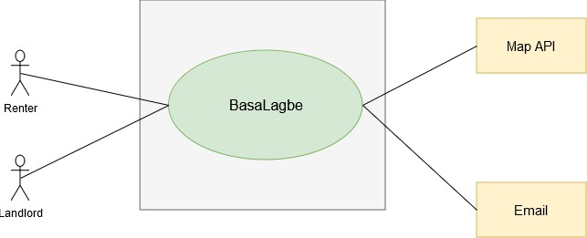
Fig 1: Level 0 of Use Case Diagram

Level 1:

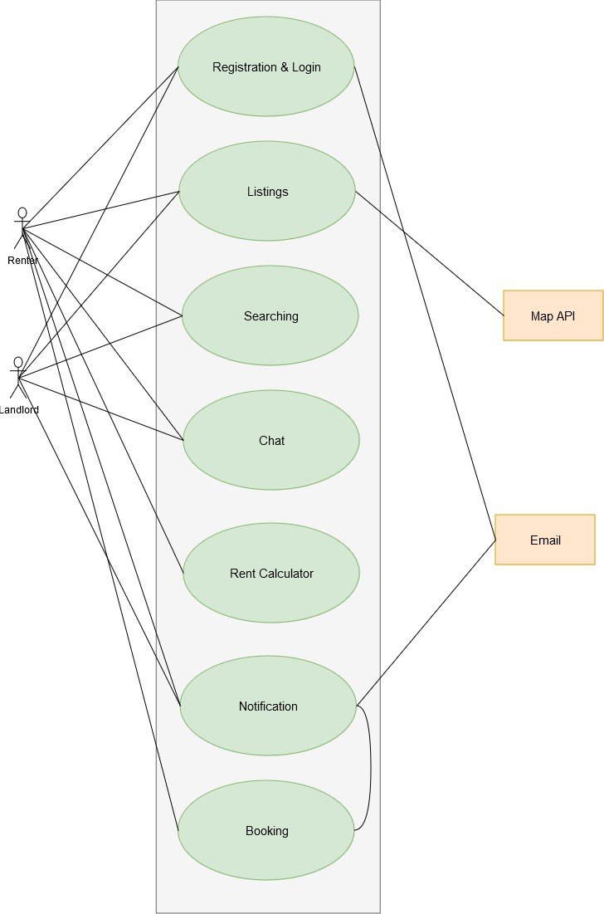
Primary actors: Renters, Landlords, Admin Secondary actor: Map API, Email
Fig 2: Level 1 of Use Case Diagram

Level 1.1:

Name: Registration

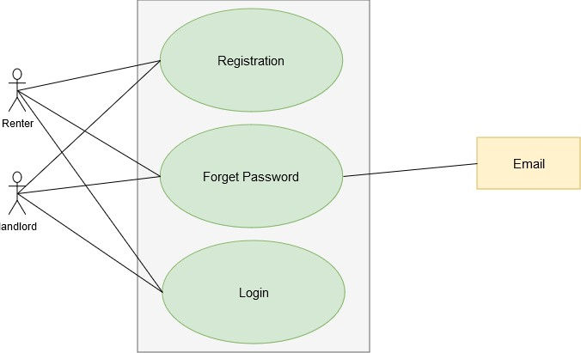
Primary actors: Renter, Landlord Secondary actress: Email
Fig 3: Level 1.1 of Use Case Diagram

Registration
- Action:
  - The renter or landlord provides personal details (e.g., name, email, password).
  - The system validates the input and checks if the email is unique.
- Reply:
  - A success message is shown upon successful registration.
  - If there's an error (e.g., duplicate email), an error message is displayed.

Login
- Action:
  - The renter or landlord enters their email and password.
  - The system verifies the credentials against the database.
- Reply:
  - Successful login leads to dashboard access.

  - If login fails, an error message is displayed (e.g., "Invalid credentials").

Forget Password
- Action:
  - The renter or landlord enters their registered email.
  - The system checks if the email exists in the database.
  - If valid, a password recovery email is sent.
- Reply:
  - A confirmation message is shown (e.g., "Recovery email sent").
  - If the email is not registered, an error message is displayed (e.g., "Email not found").

Level 1.2:

Name: Listings

Primary actors: Landlord Secondary actors: Renter, Map API

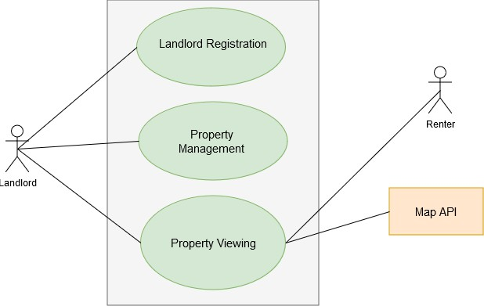
Fig 4: Level 1.2 of Use Case Diagram

Landlord Registration
- Action:
  - The landlord enters their details (e.g., name, email, password, contact info).
  - The system validates the input and checks for duplicate records.
- Reply:
  - Successful registration message: "Account created successfully."
  - Error message for issues like duplicate email or invalid inputs: "Email already exists" or "Please enter valid information."

Property Management
- Action:
  - The landlord or admin:
    - Adds new properties (e.g., address, rent, features).
    - Updates existing property details (e.g., availability, price).
    - Deletes properties no longer available.
- Reply:
  - Success messages:
    - "Property added successfully."
    - "Property details updated."
    - "Property removed successfully."
  - Error messages for validation or system errors:
    - "Unable to add property. Please try again."
    - "Invalid details. Check inputs."

Property Viewing
- Action:
  - The renter searches for properties based on preferences (e.g., location, price).
  - The system retrieves matching properties and displays them.
  - A Map API is used to show property locations.
- Reply:

  - Search results: List of properties with details (e.g., name, rent, address).
  - Map interface showing locations.
  - Error message if no properties match the search: "No properties found matching your criteria."

Level 1.2.2:

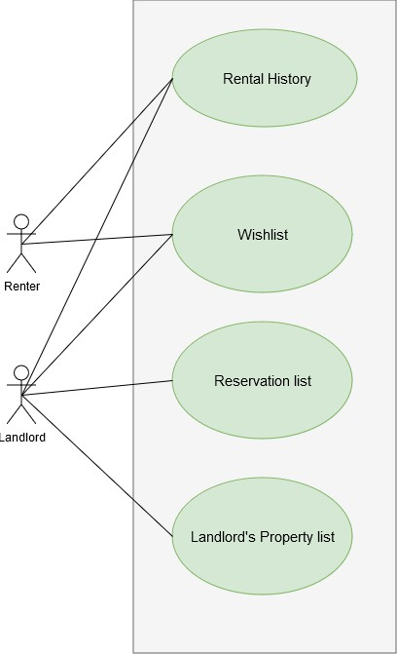
Name: View listings & details Primary actors: Landlord, renter
Fig 5: Level 1.2.2 of Use Case Diagram

Rental History
- Action:
  - The renter views their past rental records (e.g., property details, rental period, payments).
- Reply:
  - Displays a list of past rentals with details like dates, amounts paid, and property addresses.
  - Error message if no rental history exists: "No rental records found."

Wishlist
- Action:
  - The renter adds properties to their wishlist for later review.
  - The renter views or removes properties from the wishlist.
- Reply:
  - Success message for actions:
    - "Property added to wishlist."
    - "Property removed from wishlist."
  - Displays the wishlist with property details.
  - Error message if no properties are in the wishlist: "Your wishlist is empty."

Reservation List
- Action:
  - The landlord views a list of renters who have requested reservations for their properties.
  - The landlord accepts or rejects reservation requests.
- Reply:
  - Displays the list of reservations with renter details (e.g., name, date, status).
  - Success message for actions:
    - "Reservation accepted."
    - "Reservation rejected."
  - Error message if no reservations are pending: "No reservation requests found."

Landlord's Property List
- Action:
  - The landlord views a list of all properties they have listed.
  - The landlord updates property details or removes a property from the list.
- Reply:
  - Displays the property list with details (e.g., address, rent, availability status).
  - Success message for updates or removals:
    - "Property updated successfully."
    - "Property removed successfully."
  - Error message if no properties are listed: "You have no properties listed."

Level 1.3:

Name: Searching

Primary actors: Renter, landlord
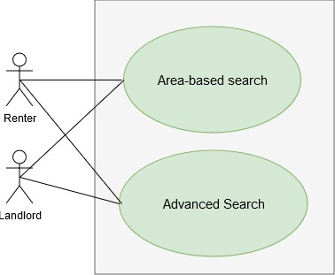
Fig 6: Level 1.3 of Use Case Diagram

Area-Based Search

- Action:
  - The renter selects a specific area or city (e.g., Dhaka neighborhoods like Gulshan, Banani, etc.).

  - The system fetches properties available in the selected area.
- Reply:
  - If properties are available:
    - Displays a list of properties with details (e.g., name, rent, size, amenities, and images).
    - Provides a map view showing property locations (if integrated with Map API).
  - If no properties are available:
    - Displays a message: "No properties found in this area. Please try another location."

Advanced Search
- Action:
  - The renter applies additional filters, such as:
    - Price range: Min and max rent.
    - Number of bedrooms: Studio, 1BHK, 2BHK, etc.
    - Property type: Apartment, house, shared rooms.
    - Amenities: Parking, elevator, pool, etc.
    - Availability date: Immediate or future availability.
    - Furnishing: Fully furnished, semi-furnished, or unfurnished.
  - The system processes these filters and retrieves properties that match all criteria.
- Reply:
  - If properties match the filters:
    - Displays the list of properties with detailed information and images.
    - Provides a comparison option (if supported) to evaluate properties side-by-side.
  - If no properties match:
    - Displays a message: "No properties found matching your criteria. Try modifying your filters."

Level 1.4:

Name: Notifications and Booking Primary actors: Landlord Secondary actors: Email
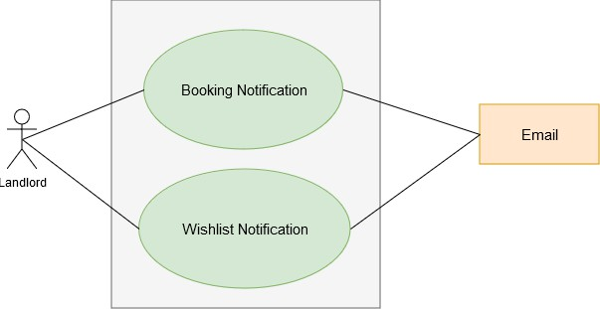
Fig 7: Level 1.4 of Use Case Diagram

WishList Notifications

Action:

- Trigger:
  - A renter adds a landlord's property to their wishlist.
- System Action:
  - The system sends a notification to the landlord informing them about the addition.
Reply:

- Notification Content:
  - "A renter has added your property [Property Name] to their wishlist."
  - Option for the landlord:
    - "View Property Details" (to see which property was added).
    - Optionally view a list of renters who added the property to their wishlists (if the system supports this).

Schedule Notifications

Action:

- Trigger:
  - A renter schedules a visit for a property listed by the landlord.
- System Action:
  - Send a notification to the landlord about the scheduled visit.

Reply:

- For New Visit Requests:
  - Notification Content:
    - "A renter has scheduled a visit for your property [Property Name] on [Date & Time]."
    - Options for the landlord:
      - "Approve Schedule" (confirms the visit).
      - "Propose New Time" (suggests a new schedule).
- For Cancellations:
  - Notification Content:
    - "The visit to [Property Name] scheduled for [Date & Time] has been canceled by the renter."
    - Options for the landlord:
      - "View Property Details."
      - "Contact Renter" (if system allows direct communication).

Activity Diagram:

Level: 1.1

Name: Registration
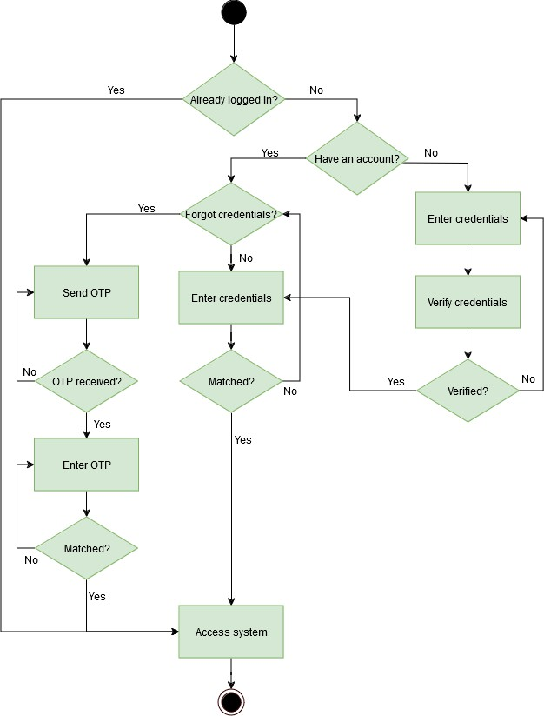
Fig 8: Level 1.1 of Activity Diagram

Level: 1.2

Name: Listings

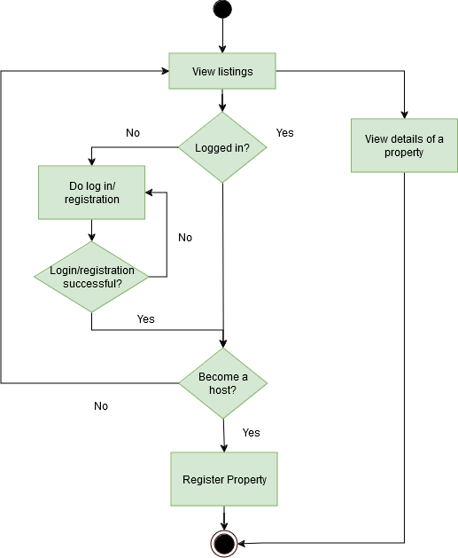

Fig 9: Level 1.2 of Activity Diagram

Level: 1.2.2

Name: View Listings and Details

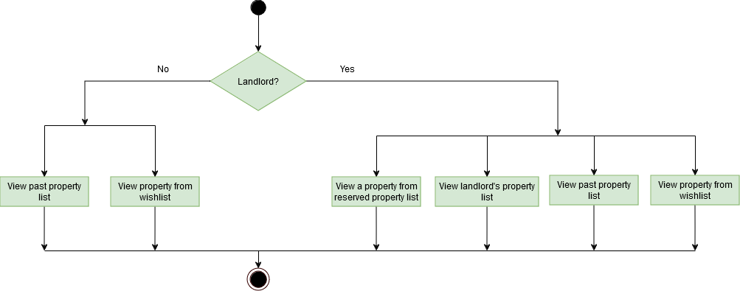
Fig 10: Level 1.2.2 of Activity Diagram

Level: 1.3

Name: Searching
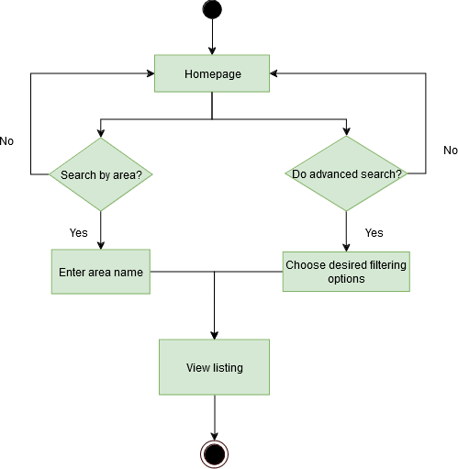
Fig 11: Level 1.3 of Activity Diagram

Level: 1.4

Name: Chat

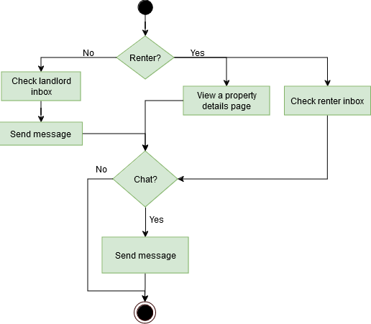
Fig 12: Level 1.4 of Activity Diagram

Level: 1.5

Name: Rent Calculator

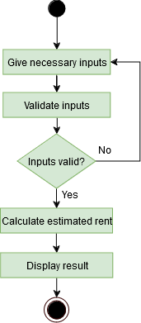
Fig 13: Level 1.5 of Activity Diagram

Level: 1.6

Name: Notification
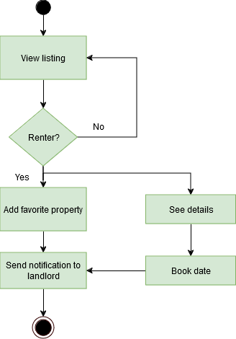
Fig 14: Level 1.6 of Activity Diagram

Swimlane Diagram:

Level: 1.1

Name: Registration
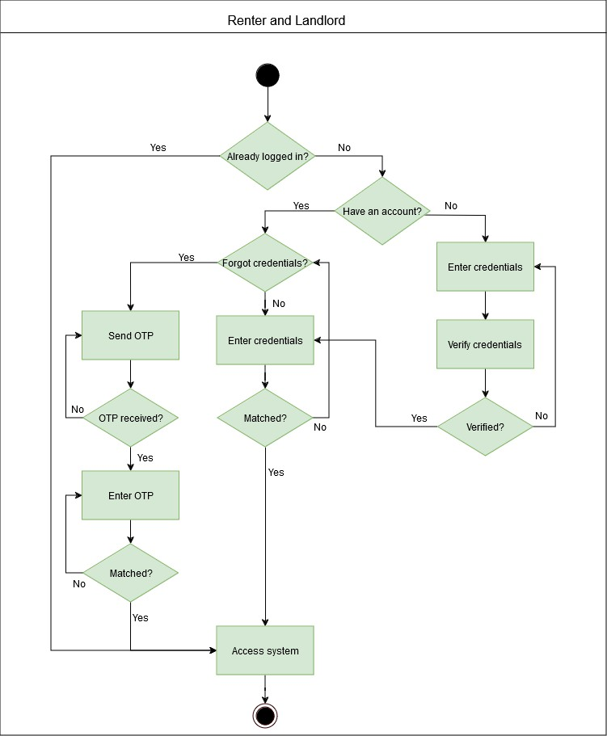
Fig 15: Level 1.1 of Swimlane Diagram

Level: 1.2

Name: Listings
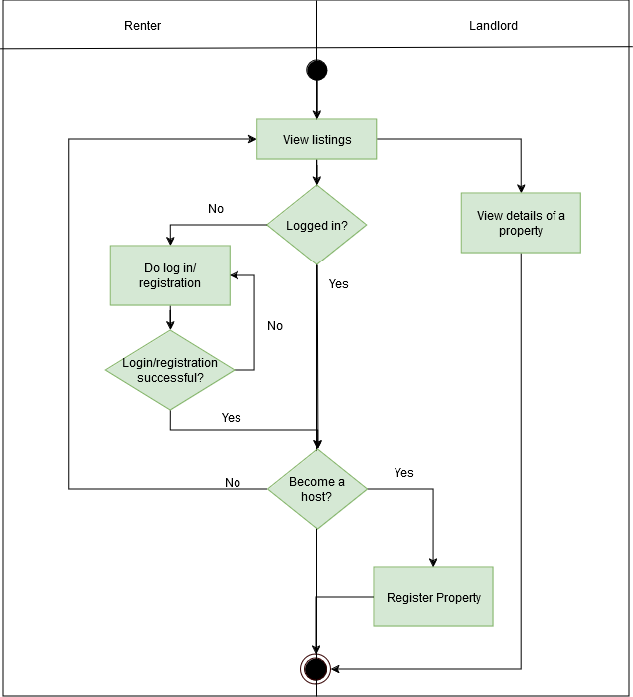
Fig 16: Level 1.2 of Swimlane Diagram

Level: 1.2.2

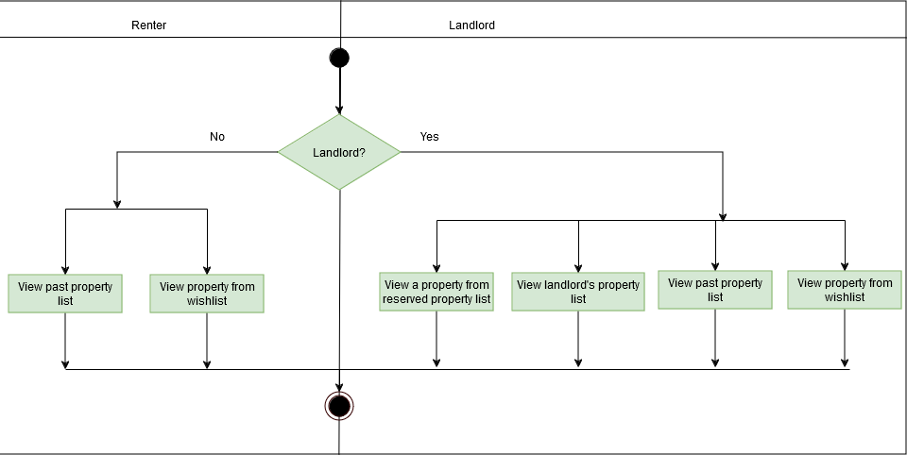
Name: View Listings and Details
Fig 17: Level 1.2.2 of Swimlane Diagram

Level: 1.3

Name: Searching
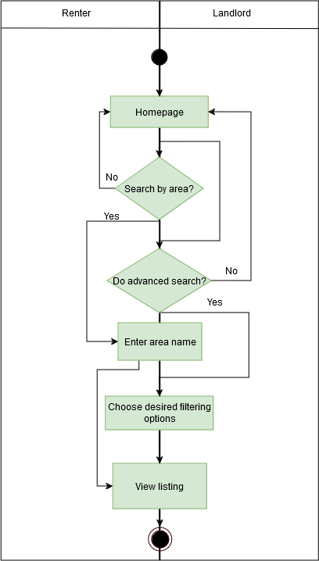
Fig 18: Level 1.3 of Swimlane Diagram

Level: 1.4

Name: Chat
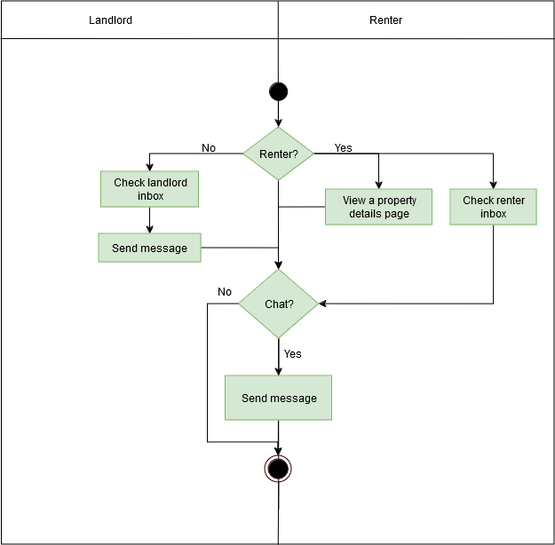
Fig 19: Level 1.4 of Swimlane Diagram

Level: 1.5

Name: Rent Calculator
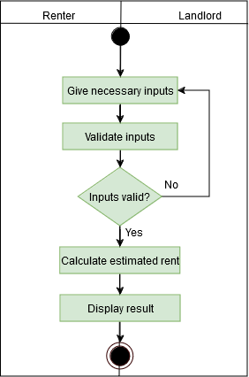
Fig 20: Level 1.5 of Swimlane Diagram

Level: 1.6

Name: Notification
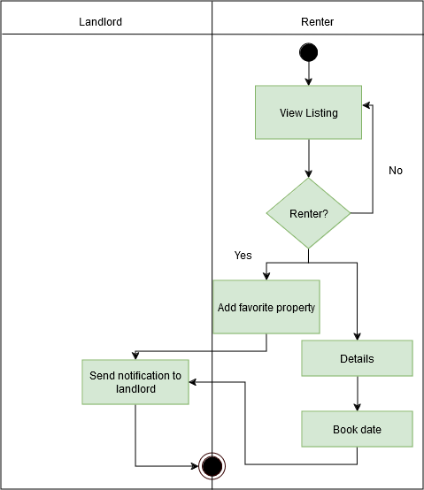
Fig 21: Level 1.6 of Swimlane Diagram

Database Modeling:
In a NoSQL database like MongoDB, data is organized into collections rather than relational tables, and each record is stored as a document instead of a row. Unlike SQL, where entities are represented as separate tables with strict relationships, MongoDB allows for a more flexible schema with embedded documents and references.

Entity Identification

SL | Nouns | Problem/Sol ution Space | Attributes
1 | User | S | 4,5,6,7,9,23,25,26,33
2 | Renter | S | 4,5,6,7,8,22,26,33
3 | Landlord | S | 4,5,6,7,9,23,25,26,33
4 | Name | S
5 | Email | S
6 | Photo | S
7 | password | S
8 | renter_id | S
9 | landlord_id | S
10 | Type | S
11 | Room_no | S
12 | Bathroom_no | S
13 | amenities | S
14 | pictures | S
15 | house _size | S
16 | Profile | P
17 | Location | S

18 | features | P
19 | Price | S
20 | Availability | S
21 | Information | P
22 | wishlist | S
23 | Reservation List | S
24 | listings | P
25 | Property_list | S
26 | Chat | S
27 | Booking | S | 8,9,34,35,46
28 | Accessibility | P
29 | Notification | S | 8,9,26
30 | Map | S
31 | Details | P
32 | Calculator | S
33 | Contact_details | S
34 | Property_id | S
35 | Date | S
36 | Description | S
37 | Home | P
38 | Preferences | P
39 | Person | P
40 | Surroundings | P
41 | Listing | S | 9,10,11,12,13,14,15,17,19,2  0,30,34,36
42 | Message | S | 8,9,26

43 | OTP | S | 8,44
44 | Timestamp | S
45 | Status | S
46 | Time | S
47 | Area | S | 50,4
48 | Longitude | S
49 | Latitude | S
50 | Description

Collections:
For this system, we identified the following core collections after analysing the table above and our system requirements:
- User – Stores user details (both renters and landlords).
- Listing – Represents property listings with relevant details.
- Booking – Manages reservations for properties.
- Message – Stores conversations between users.
- Notification – Keeps track of user notifications.

Document Schema Diagram

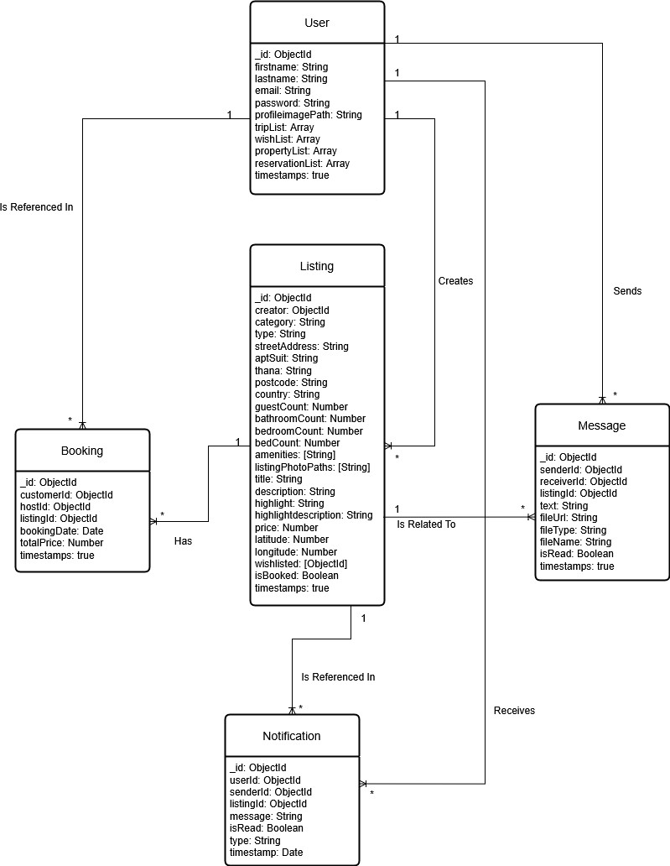
Fig 22: Document Schema Diagram

Schema Design:

Collection | Design
User | {  "_id": ObjectId, "firstname": String, "lastname": String, "email": String, "password": String, "profileimagePath": String, "tripList": Array,  "wishList": Array, "propertyList": Array, "reservationList": Array, "timestamps": true  }
Booking | {  "_id": ObjectId, "customerId": ObjectId, "hostId": ObjectId, "listingId": ObjectId, "bookingDate": Date, "totalPrice": Number, "timestamps": true  }
Message | {  "_id": ObjectId, "senderId": ObjectId, "receiverId": ObjectId, "listingId": ObjectId, "text": String,  "fileUrl": String, "fileType": String, "fileName": String, "isRead": Boolean, "timestamps": true  }
Notification | {  "_id": ObjectId, "userId": ObjectId, "senderId": ObjectId, "listingId": ObjectId, "message": String, "isRead": Boolean, "type": String,

"timestamp": Date
}
Listing | {  "_id": ObjectId, "creator": ObjectId, "category": String, "type": String, "streetAddress": String, "aptSuit": String, "thana": String, "postcode": String, "country": String, "guestCount": Number,  "bathroomCount": Number, "bedroomCount": Number, "bedCount": Number, "amenities": [String], "listingPhotoPaths": [String], "title": String,  "description": String, "highlight": String, "highlightdescription": String, "price": Number,  "latitude": Number, "longitude": Number, "wishlisted": [ObjectId], "isBooked": Boolean, "timestamps": true  }

Class Based Modeling:

Class Based Modeling Concept:
Class-based modeling represents the objects that the system will manipulate, the operations that will be applied to the objects, relationships between the objects and the collaborations that occur between the classes that are defined.

Analysis Class Identification:

SL | Nouns
1 | Market
2 | Renter
3 | Landlord
4 | Name
5 | Email
6 | Photo
7 | password
8 | renter_id
9 | landlord_id
10 | Type
11 | Room_no
12 | Bathroom_no

13 | amenities
14 | pictures
15 | house _size
16 | Profile
17 | Location
18 | features
19 | Price
20 | Availability
21 | Information
22 | wishlist
23 | Reservation List
24 | listings
25 | Property_list
26 | Message
27 | Schedule
28 | Accessibility
29 | Notification
30 | Map
31 | Details
32 | Rent Calculator
33 | Contact_details
34 | Property_id
35 | Date
36 | Description
37 | Home

38 | Preferences
39 | Person
40 | Surroundings
41 | Property
42 | Chat
43 | Status
44 | OTP
45 | Timestamp
46 | Notification
47 | Service
48 | Search Service
49 | Area
50 | longitude
51 | Latitude
52 | Calculator

List of Verbs in User Story:

SL | Verbs
1 | Register
2 | Log in

3 | Create
4 | Personalize
5 | Access
6 | List
7 | Update
8 | Delete
9 | Include
10 | Advertise
11 | View
12 | Manage
13 | Choose
14 | Filter
15 | Match
16 | Find
17 | Make
18 | Input
19 | Estimate
20 | Select
21 | Schedule
22 | Receive
23 | Become
24 | Keep
25 | Obtain
26 | Switch
27 | Show

28 | Understand
29 | Help
30 | Communicate
31 | Enable

General Classification:
Candidate classes were then characterized in seven general classes.
The
seven general characteristics are as follows:
- External entities
- Things
- Events
- Roles
- Organizational units
- Places
- Structures

SL | Nouns | General Classifications
1 | Market
2 | Renter | 1, 4, 3
3 | Landlord | 1, 4, 5
4 | Name | 2
5 | Email | 2
6 | Photo | 2,
7 | password | 2
8 | renter_id | 2

9 | landlord_id | 2,
10 | Type | 7
11 | Room_no | 7
12 | Bathroom_no | 7
13 | amenities | 7, 2
14 | pictures | 2, 7
15 | house _size | 2, 7
16 | Profile | 2, 7, 4
17 | Location | 6, 7
18 | features | 7, 2
19 | Price | 2, 7
20 | Availability | 3, 2
21 | Information | 3, 2
22 | wishlist | 2, 3, 7
23 | Reservation List | 3, 7, 2
24 | listings | 2, 5,7
25 | Property_list | 2, 5,7
26 | Message | 2, 3
27 | Schedule | 3, 7, 2
28 | Accessibility | 7
29 | Notification | 3, 2
30 | Map | 6, 2
31 | Details | 2, 3
32 | Rent Calculator | 2,7
33 | Contact_details | 2

34 | Property_id | 2, 7
35 | Date | 3, 2
36 | Description | 2
37 | Home | 6
38 | Preferences | 2, 3
39 | Person | 1, 4
40 | Surroundings | 6, 7
41 | Listing | 2, 6, 7
42 | Message | 2, 3,7
43 | Status | 2
44 | OTP | 2,3,7
45 | Timestamp | 2
46 | Notifications | 2,3,7
47 | Search service | 1,2,3
48 | Service | 1,2,3
49 | Conversation | 2,3,7
Potential To Be A Class:

  - Renter
  - Landlord
  - Listings
  - Message
  - Notifications
  - Schedule

  - Property
  - OTP
  - Notifications
  - Service
  - Search service

Analysis: As rent calculator has a specific and crucial role in our system, it will also be considered as a potential class.

  - Rent calculator

Selection Criteria:
The candidate classes are then selected as classes by six Selection Criteria. A
candidate class generally becomes a class when it fulfills around three characteristics.
- Retain information
- Needed services
- Multiple attributes
- Common attributes
- Common operations
- Essential requirements
Potential general classified nouns to become a class after selection criteria:

SL | Nouns | Selection Criteria
1. | Market
2. | Renter | 1, 2, 3, 4, 5
3. | Landlord | 1, 2, 3, 4, 5
4. | Wishlist | 1, 2, 3, 4, 5
5. | Reservation List | 1, 2, 3,4, 5
6. | Listings | 1, 2, 3, 6
7. | Property_list | 1, 2, 3,4, 5
8. | Schedule | 1, 2, 3,4, 5
9. | Message | 2, 3, 4, 6
10. | Property | 6
11 | Profile | 1,3,5
12 | OTP | 1,2,3,4,5
13 | Notifications | 1,2,3,4,5
14 | Service | 2,5,6
15 | Search Service | 2,5,6
16 | Conversation | 2,3,4,6
17 | Rent Calculator | 2,3,6

Selected Class:

In the development of this application, we adopted a modular and structured approach using route controllers to organize the backend logic. While Object-Oriented Programming (OOP) was

not explicitly used, the decision to implement route controllers aligns with the MERN stack's best practices for building scalable and maintainable web applications.

To ensure clarity and maintainability, we represented each route controller as a class, with its attributes and methods clearly defined. This approach provides a structured way to encapsulate related functionality and makes the codebase easier to understand and extend.

Following is the list of classes that we have identified after careful analysis of the tables above and our system requirements:

  - AuthController
  - BookingController
  - ListingController
  - MessageController
  - NotificationController
  - PredictionController
  - UserController

Attributes and Method Identification:

Class | Attributes | Methods
AuthController | otpStore: Object upload: Multer Instance  transporter: Nodemailer Transporter | constructor() initializeRoutes() register(req, res) login(req, res) forgotPassword(req, res) resetPassword(req, res)
BookingController | router: Express Router | constructor() initializeRoutes() createBooking(req, res)
ListingController | router: Express Router | constructor() initializeRoutes() uploadPhotos() createListing(req, res) getListings(req, res) searchListings(req, res) getListingById(req, res) deleteListing(req, res)

 |  | updateListing(req, res) addToWishlisted(req, res) removeFromWishlisted(req, res) getWishlistedUsers(req, res)
MessageController | router: Express Router | constructor() initializeRoutes()  getMessagesByListingAndUsers (req, res)  createMessage(req, res) uploadFile(req, res) getFile(req, res) getInbox(req, res)
NotificationControll er | router: Express Router | constructor() initializeRoutes()  getNotificationsByUser(req, res) createNotification(req, res) markNotificationAsRead(req, res)  deleteNotification(req, res) deleteAllNotificationsForUser(re q, res) sendEmailNotification(userId, message)
PredictionController | router: Express Router | constructor() initializeRoutes() makePrediction(req, res)
UserController | router: Express Router | constructor() initializeRoutes() getTrips(req, res) toggleWishlist(req, res) getProperties(req, res) getReservations(req, res) getUserDetails(req, res) removeFromWishlist(req, res)

Class Cards:
ID:1

Class: AuthController
Responsibilities | Collaborators
Handles user authentication and authorization. | UserController
Manages OTP-based verification. | UserController
Handles password reset functionality. | UserController

ID:2

Class: BookingController
Responsibilities | Collaborators
Manages booking-related operations. | UserController, ListingController
Creates new bookings. | UserController, ListingController

ID:3

Class: ListingController
Responsibilities | Collaborators
Manages listing-related operations.
Manages wishlist functionality.

ID:4

Class: MessageController
Responsibilities | Collaborators
Manages messaging between users. | UserController, ListingController
Handles file uploads and retrieval. | UserController

ID:5

Class: NotificationController
Responsibilities | Collaborators
Manages user notifications. | UserController
Handles CRUD operations for notifications. | UserController
Sends email notifications. | UserController, ListingController

ID:6

Class: PredictionController
Responsibilities | Collaborators
Estimates rent of property

ID:7

Class: UserController
Responsibilities | Collaborators
Handles trips, wishlists, properties, and reservations. | ListingController
Manages user-related operations.
Retrieves user details.

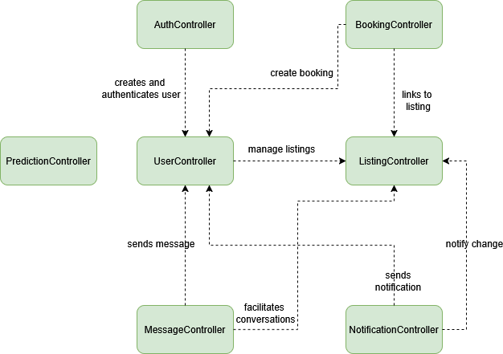
CRC Diagram: ID:1

Fig 23: CRC Diagram

Behavioral Modeling

Behavioral modeling is the process of predicting future behavior using current and relevant data on consumer and company spending. There are two distinct characterizations of states that must be taken into account in behavioral modeling. First, the state of each class as the system executes its task, and then the system's state as seen from the outside while the system executes its task.

State Transition Diagram

A UML state diagram, which depicts the active states for each class and the occasions (triggers) that induce changes between these active states, is a part of a behavioral model. Here we’ve listed the most important events that trigger the change of states.

List of Events

SI | Initiator Class | Event | Collaborator Class
01 | Renter | Update profile
02 | Renter | Add details
03 | Renter | View wishlist | WishList
04 | Renter | Search properties | SearchService, Listings
05 | Landlord | Host property | Property_list, Listings
06 | Landlord | Remove property | Property_list
07 | Landlord | See reservation list | Reservation_list
08 | Landlord | See wishlist | See wishlist

09 | Landlord | View property details | Property
10 | Landlord | View notifications | Notification
11 | Service | Register | Renter, Landlord
12 | Service | Login | Renter, Landlord
13 | Service | Logout
14 | Service | Authenticate | OTP
15 | Wishlist | Add to wishlist | Renter, Landlord, Property
16 | Wishlist | Remove from wishlist | Renter, Landlord, Property
17 | Wishlist | Create notification | Notification
18 | Reservation_list | Add reservation | Renter, Landlord, Property
19 | Reservation_list | Cancel reservation | Landlord
20 | Reservation_list | View reservation details | Landlord
21 | Property_list | Create property list | Landlord
22 | Property_list | Remove property | Landlord
23 | Property_list | Get properties | Landlord, Property
24 | Property | Register property | Landlord, Listings
25 | Property | Mark property as available
26 | Listings | Create listing | Property
27 | Listings | Update listing | Property
28 | Listings | Delete listing
29 | Listings | Search listings | SearchService
30 | Listings | View listings
31 | Schedule | Create schedule | Renter, Landlord, Property
32 | Schedule | View schedule

33 | Schedule | Create notification | Notification
34 | Message | View message | Conversation
35 | Conversation | Send message | Message
36 | Conversation | View all messages | Message
37 | OTP | Generate OTP
38 | OTP | Validate OTP
39 | OTP | Expire OTP
40 | Rent Calculator | calculate

State Transition Diagram:

ID:1
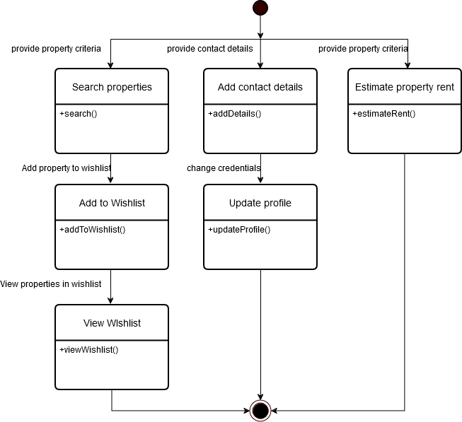
Fig 24: ID1 of State Transition Diagram

ID:2
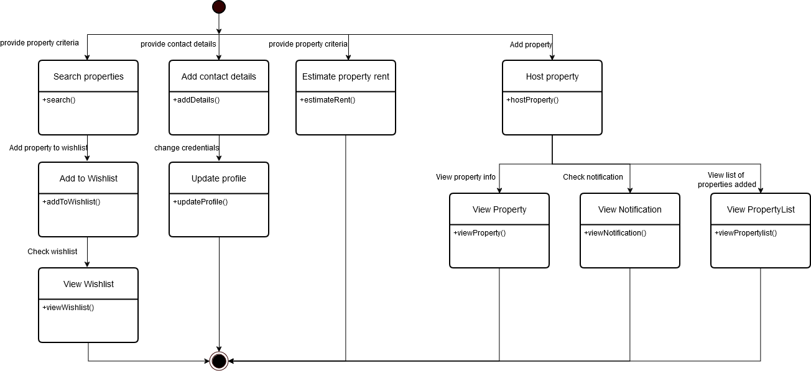
Fig 25: ID2 of State Transition Diagram

ID:3

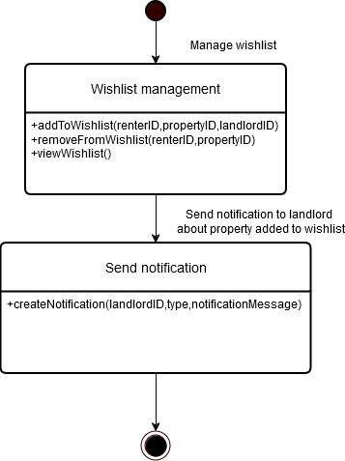
Fig 26: ID3 of State Transition Diagram

ID:4
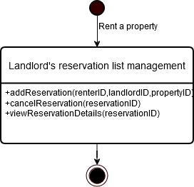
Fig 27: ID4 of State Transition Diagram

ID:5
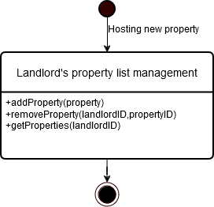
Fig 28: ID5 of State Transition Diagram

ID:6
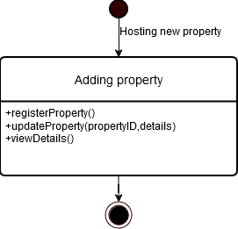
Fig 29: ID6 of State Transition Diagram

ID:7
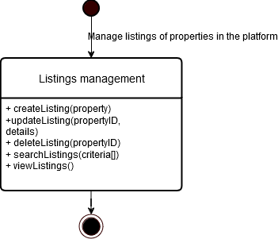
Fig 30: ID7 of State Transition Diagram

ID:8
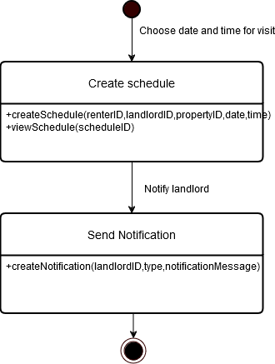
Fig 31: ID8 of State Transition Diagram

ID:9

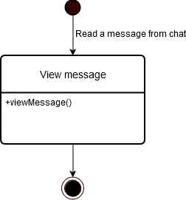
Fig 32: ID9 of State Transition Diagram

ID:10
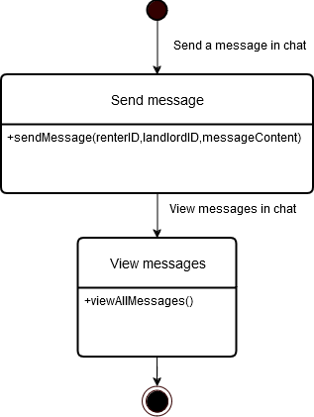
Fig 33: ID10 of State Transition Diagram

ID:11

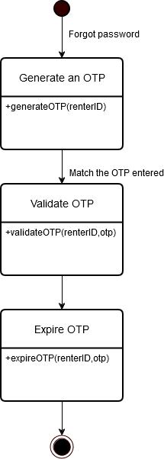
Fig 34: ID11 of State Transition Diagram
ID:12

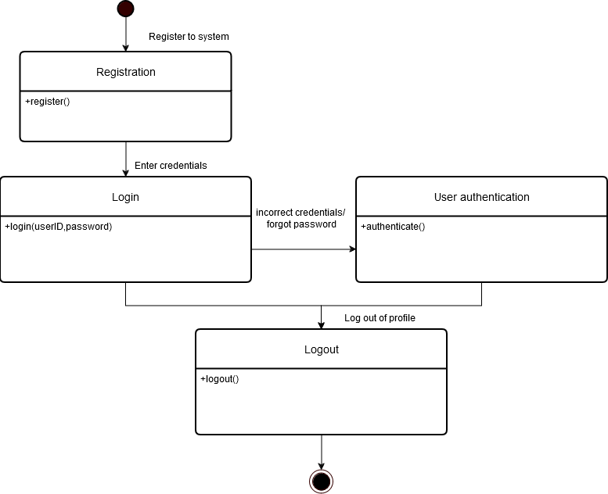
Fig 35: ID12 of State Transition Diagram

ID:13
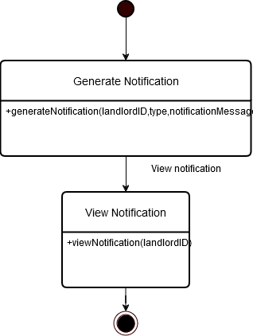
Fig 36: ID13 of State Transition Diagram

ID:14
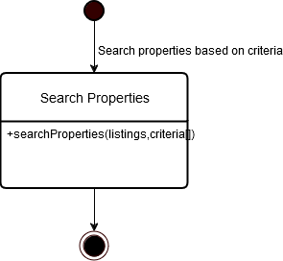
Fig 37: ID14 of State Transition Diagram

ID:15
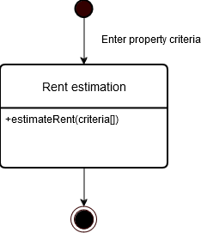
Fig 38: ID15 of State Transition Diagram

Sequence Diagram

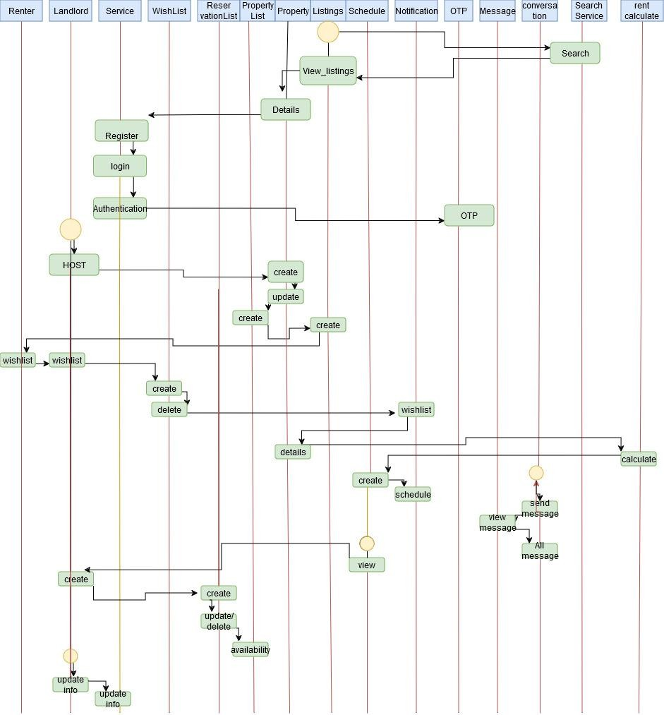

Fig 39: Sequence Diagram

Data Flow Diagram

Data Flow Diagram (DFD) represents the flow of data within information systems. Data Flow Diagrams (DFD) provide a graphical representation of the data flow of a system that can be understood by both technical and non-technical users. The models enable software engineers, customers, and users to work together effectively during the analysis and specification of requirements.

Level 0:

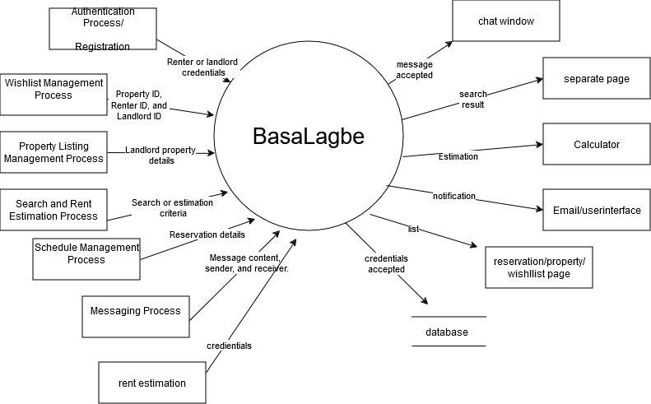
Fig 40: Level 0 of DFD

Level 1:

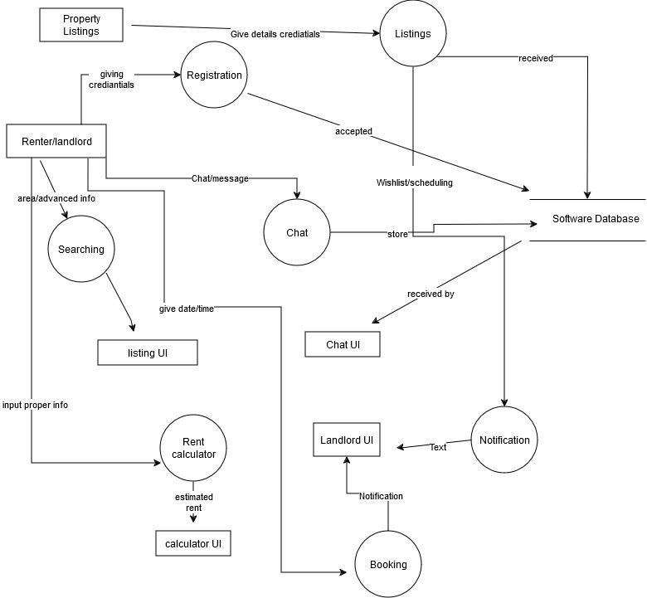
Fig 41: Level 1 of DFD

User Manual
A user manual, also known as an instruction manual, is an imperative document that aids users to get acquainted with service quickly or product or helps them resolve a problem when they need a fix. The usages are described below:

Home Page:
The homepage provides an overview of available rental properties across different areas of Dhaka. At the top, users can search for properties and access their details. A section featuring "Explore Top Houses" is followed, where users can browse properties based on location. Below that, users can filter listings by selecting a specific area or viewing all available properties. Each listing displays essential details, including location, type, and price. The bottom section contains useful links (About Us, Terms & Conditions, etc.) and contact information for support.

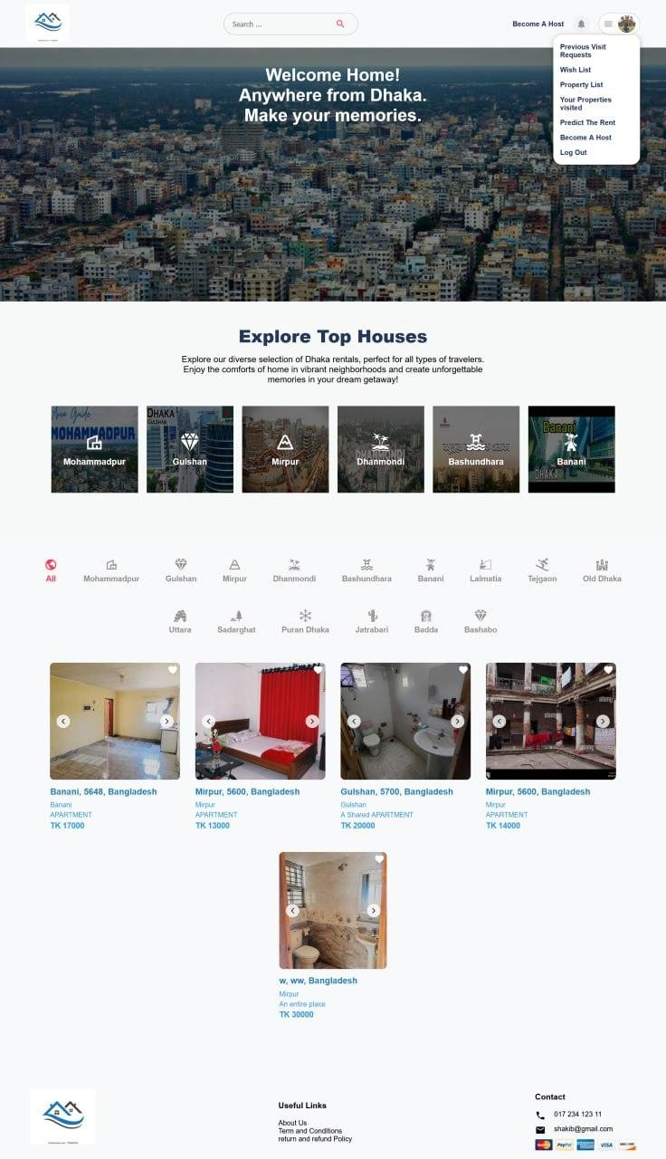
Fig 42: Homepage

Registration Page:
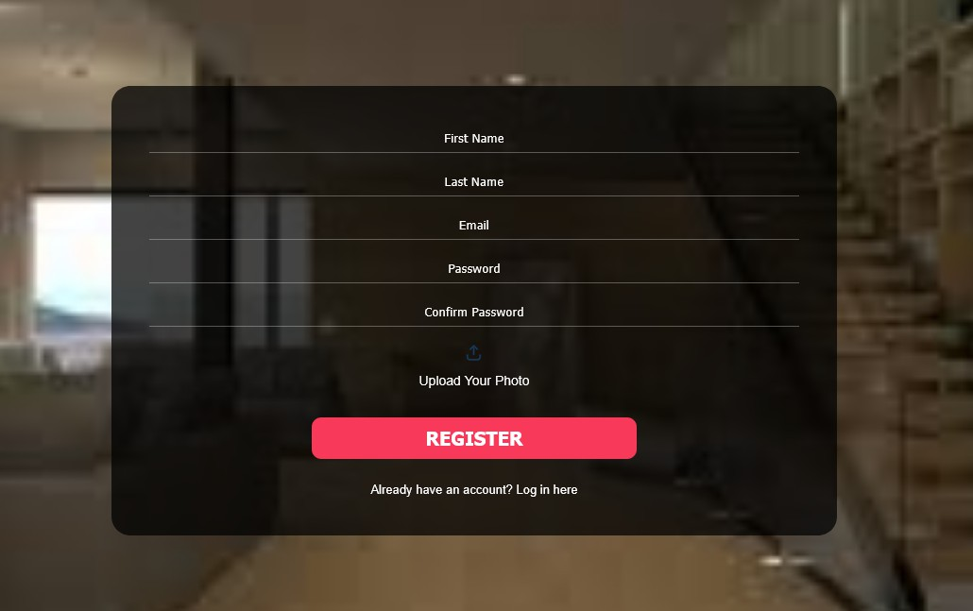
The registration page allows new users to create an account by providing their personal details. Users need to enter their first name, last name, email, and password, ensuring that the password is confirmed correctly. Additionally, they have the option to upload a profile photo. Once all the necessary fields are filled out, clicking the "REGISTER" button completes the registration process. If the user already has an account, they can navigate to the login page using the provided link.
Fig 43: Registration page

Login Page:
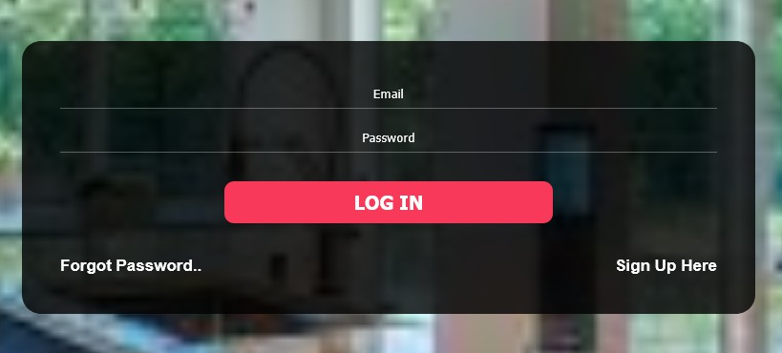
Users can enter their email and password to log in. A "Forgot Password.." link is available for password recovery, and a "Sign Up Here" link directs new users to the registration page.
Fig 44: Login page

Forgot Password:
If users forget their password, they may follow the ‘Forgot Password’ link from Login page and enter their registered email to receive an OTP for password recovery(Fig 4.1). After clicking "Send OTP," they proceed to a follow-up page(Fig 4.2), where users enter the received OTP, set a new password, and confirm it. Finally, they click "Reset
Password" to complete the process.
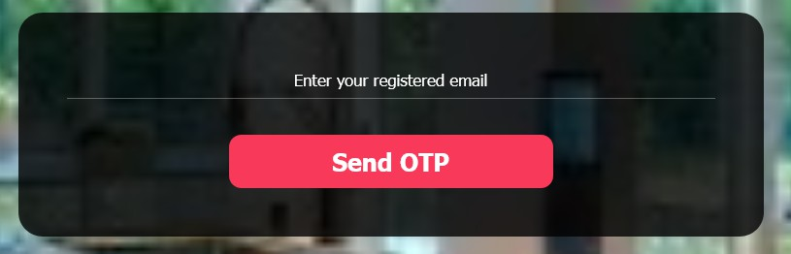
Fig 45.1: OTP page

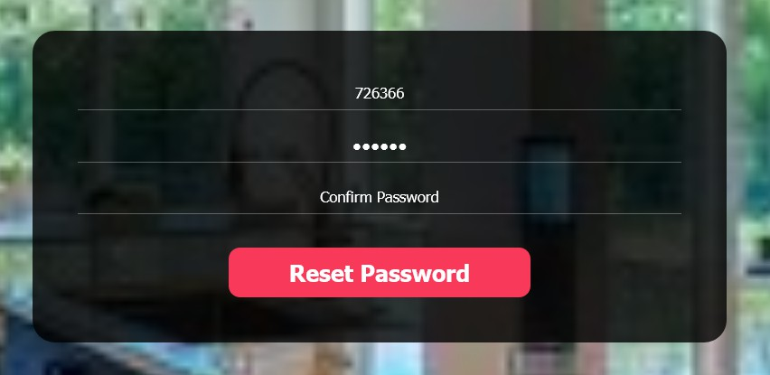
Fig 45.2: Password reset page

Searching:
A user can enter a location in the search bar at the top of the navbar, and they will be taken to a page that displays a list of available rental properties in the specified area, including details such as property type (e.g., APARTMENT, An entire place), location, and price per night. Users can further refine their search by selecting the number of bedrooms and bathrooms, and by setting a minimum and maximum price range.
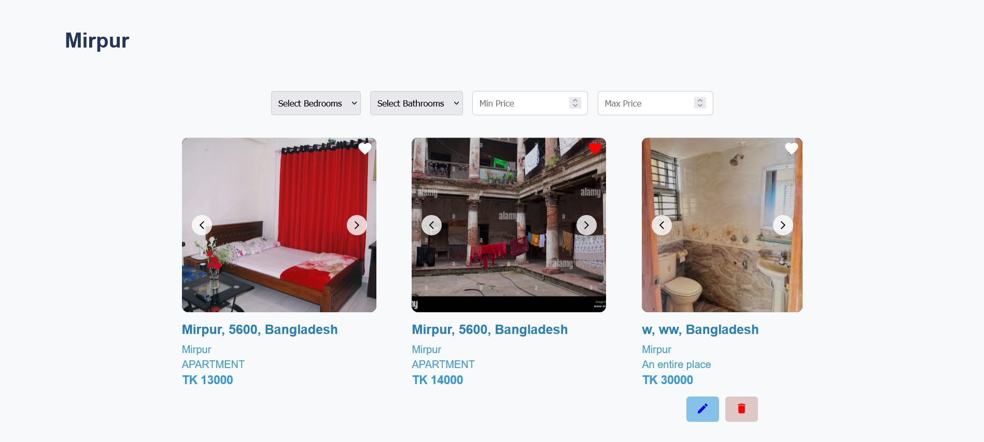
Fig 46: Rental Listings for Selected Location

Viewing Property Details from Listing:
When users select an apartment from the listing, they are directed to a detailed page for that property. This page includes the apartment's location displayed on a map, the written address, high-quality images, and a detailed description. Users can also view a calendar to schedule a visit with the owner and have the option to chat directly with the owner for further inquiries or arrangements.
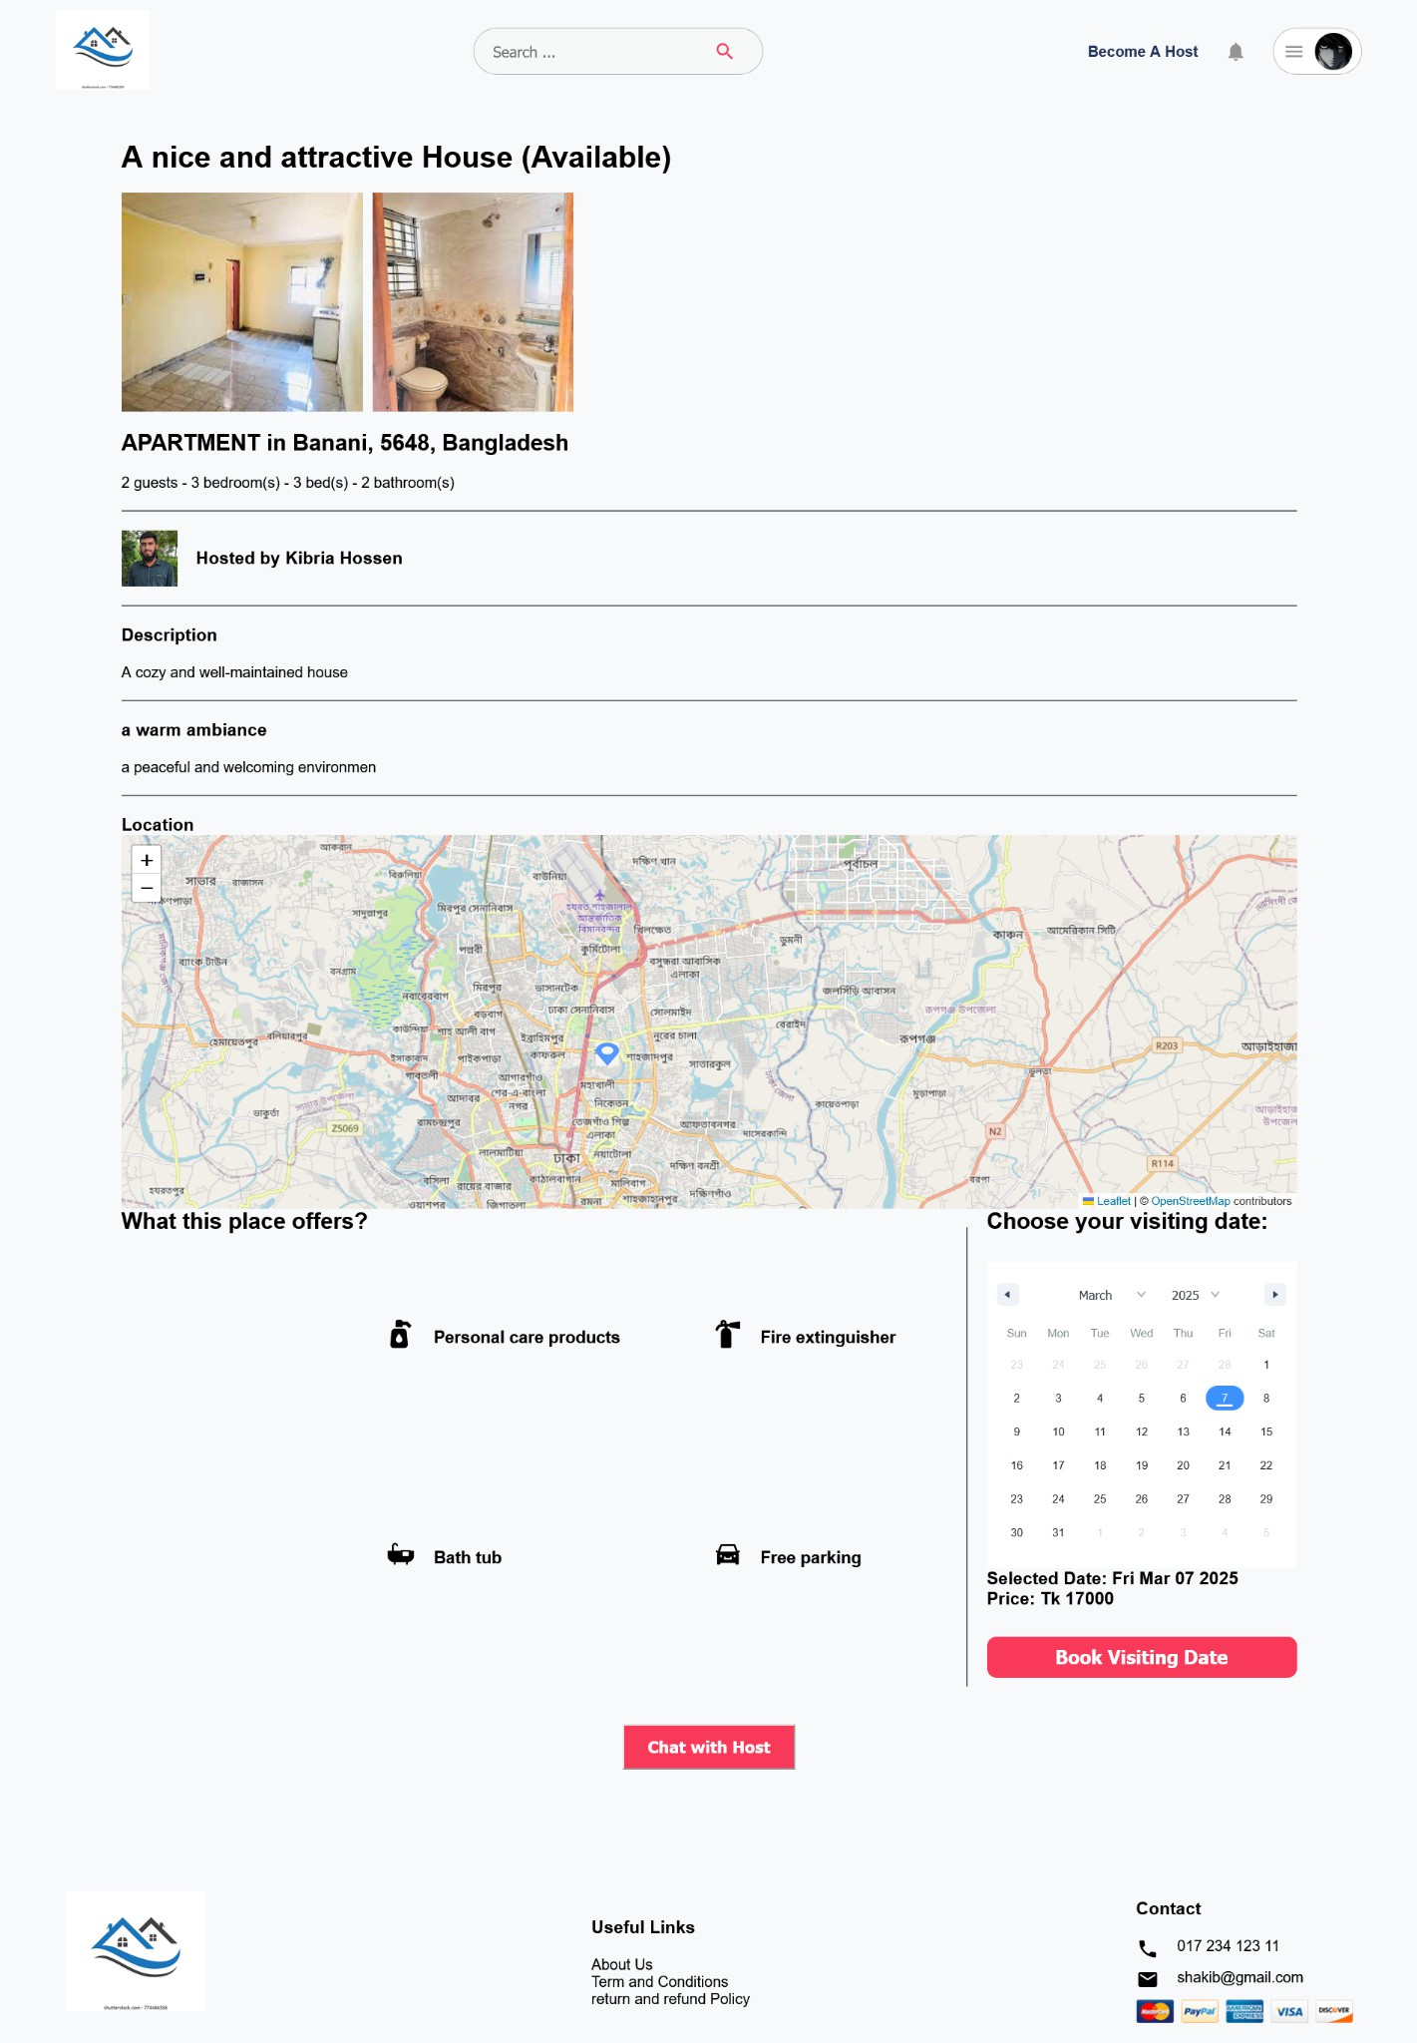

Fig 47: Property Details from Listing

Chat:
Users may select ‘Chat with Host’ from the details page of a property to chat with the property’s owner. This feature enables seamless interaction to discuss property details and arrange viewings.
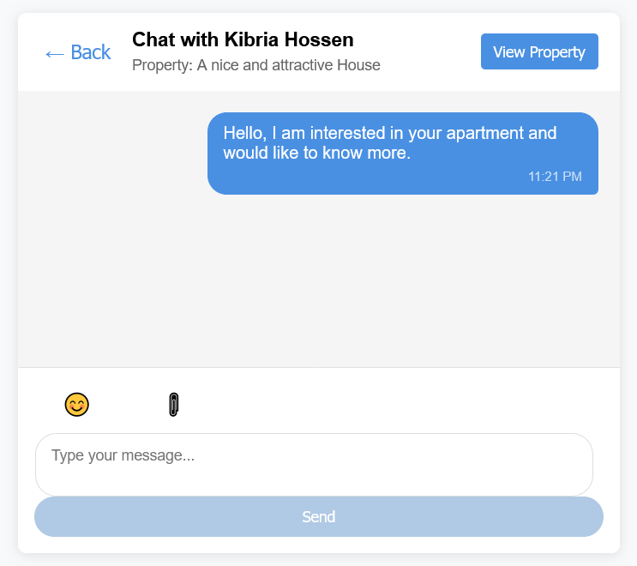
Fig 48: Chat with the property owner

Rent Prediction:
Users can select ‘Rent Prediction’ from the menu on the top right corner to get an estimate of the monthly rent in their desired location. By entering the location name, area size of the apartment, number of bedrooms and number of bathrooms, users will get an estimate of the rental price in that location, which will help them to plan their budget based on market trends. Landlords may use it to determine competitive rental pricing.

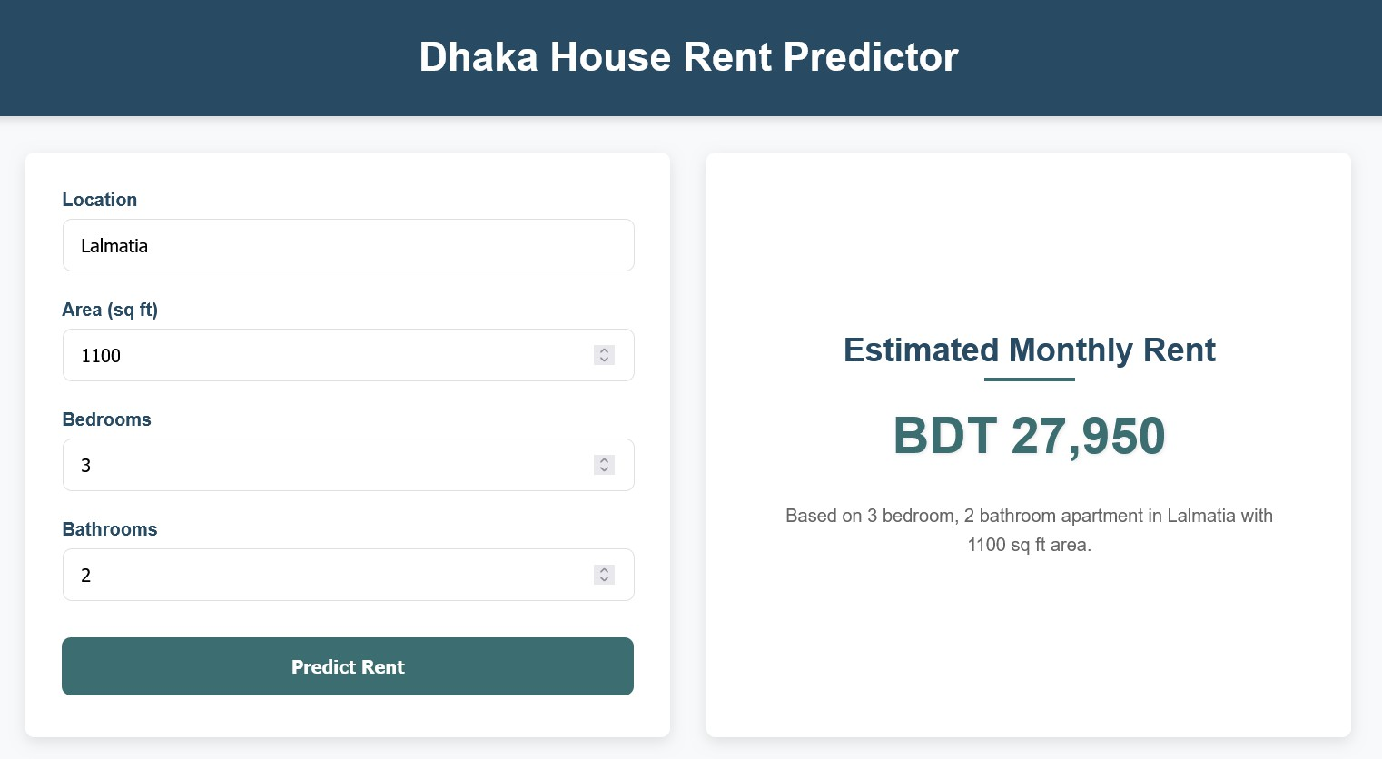
Fig 49: Rend prediction page

Hosting a Property:
When an owner wants to list their property for rent, they follow a straightforward process to provide all necessary details. First, they select the property's location on a map and choose the appropriate category that best describes the area (Fig 9.1). Next, they specify the type of place (e.g., entire place, apartment, shared apartment) and enter the complete address, including street name, apartment/suite details, postcode, thana, and country (Fig 9.2).
The owner can select the amenities available at the property, such as Wi-Fi, air conditioning, kitchen facilities, safety features, and outdoor amenities (Fig 9.3), along with the number of bedrooms and bathrooms available.The owner then adds a title and description to make the property attractive, highlighting unique features and providing details about these highlights (Fig 9.4). Finally, the owner sets the rental price and completes the listing by clicking "CREATE YOUR LISTING." This process ensures that all essential information is provided to attract potential renters and give them a comprehensive understanding of the property.

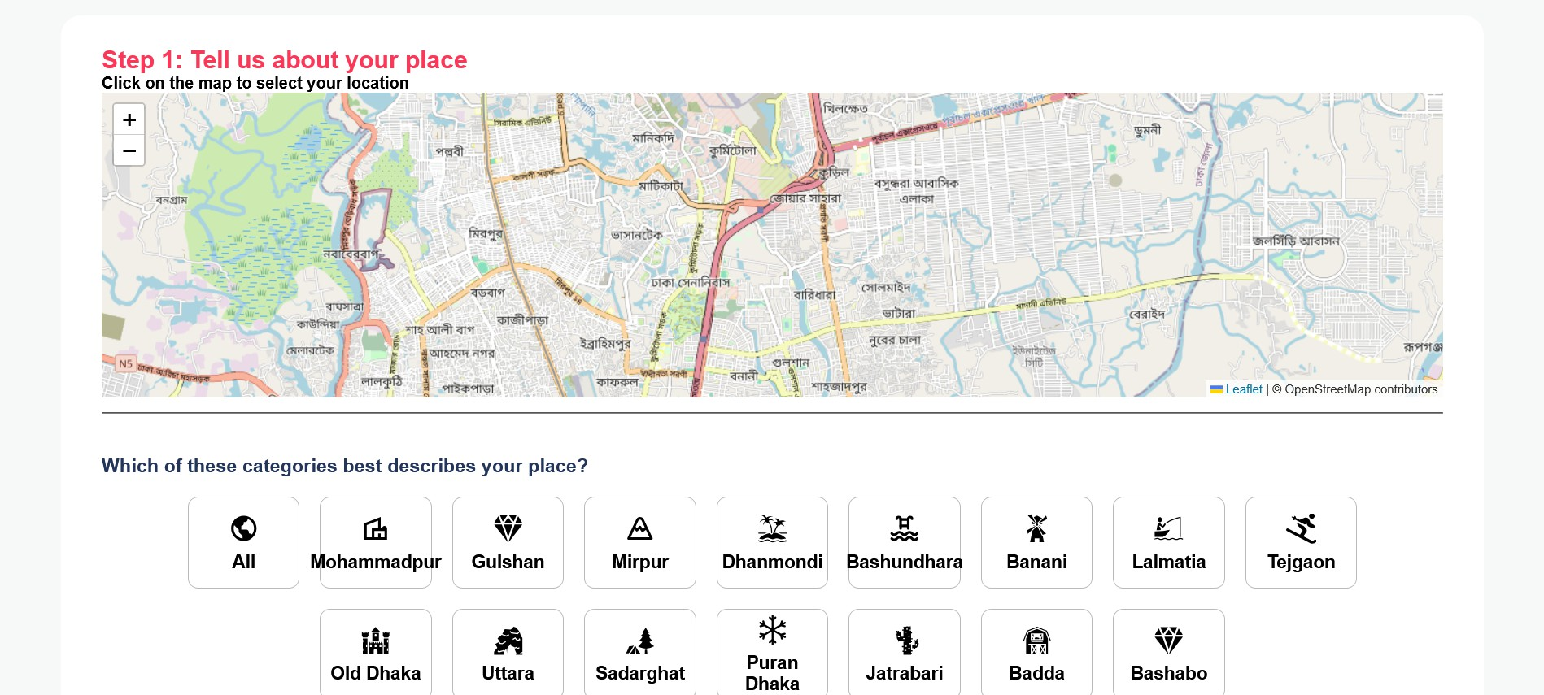
Fig 50.1: Choosing apartment location

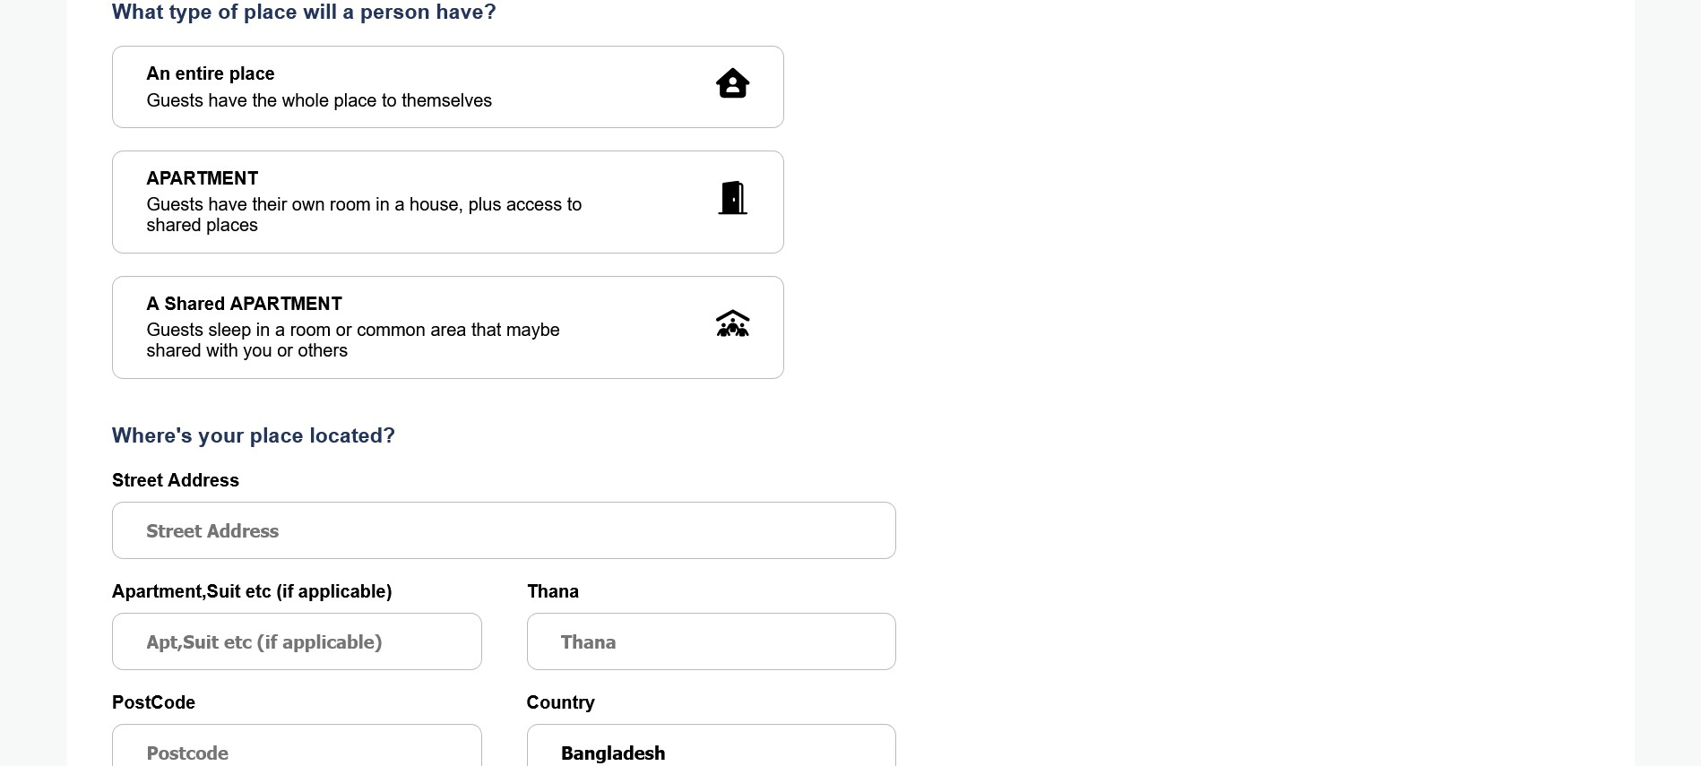
Fig 50.2: Choosing type of apartment and entering location details

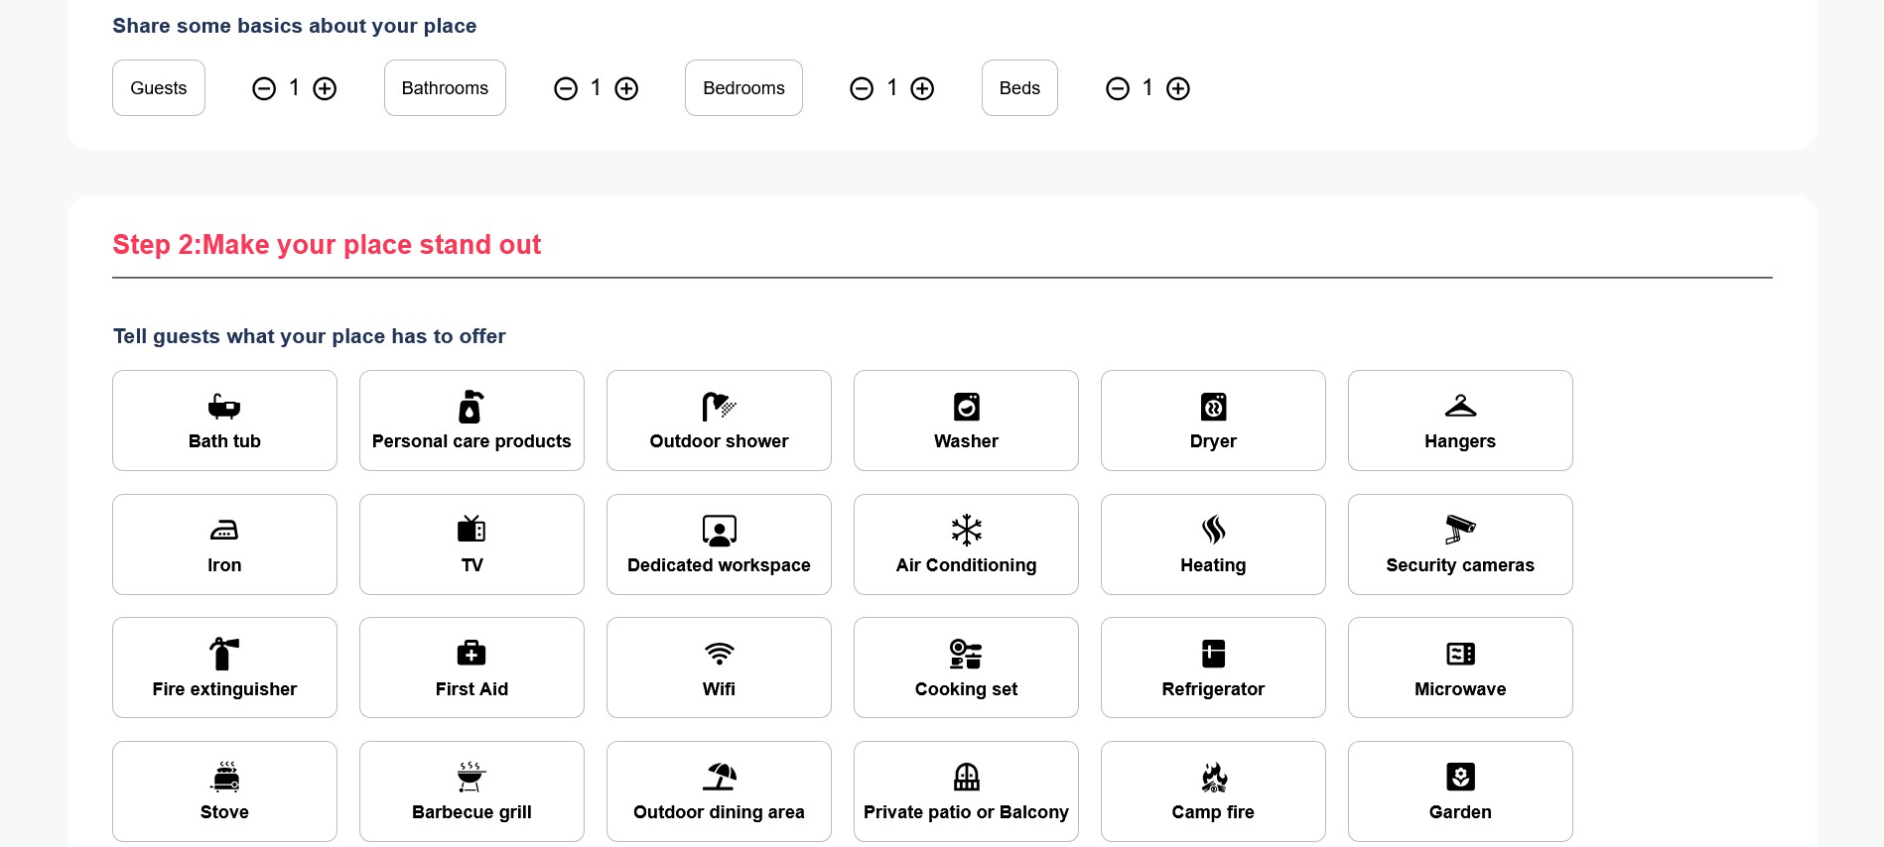
Fig 50.3: Entering basic information of apartment and choosing amenities available

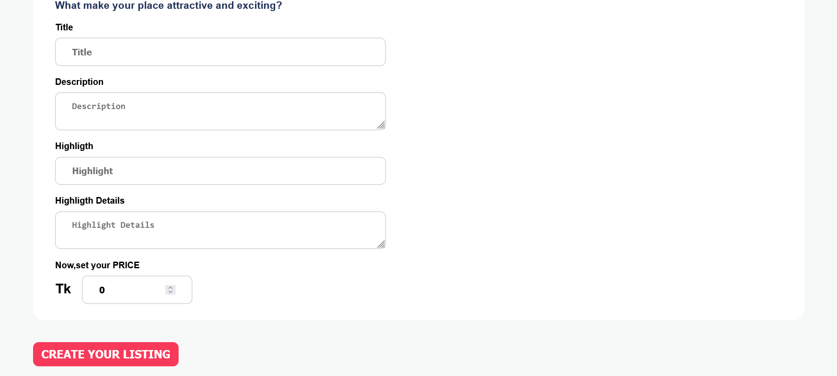
Fig 50.4: Entering details and price of the apartment

User Property Interaction Management:
Users can view four different property lists from the menu bar on the top right. They are:

- Wishlist
A collection of properties that the user has saved for future reference. Users can add a property to their wishlist by clicking on the ‘love’ icon on the listings of properties.

- Property List (Landlord)
Displays the properties that the landlord has added to the platform.

- Your Properties Visited
A list of properties that the user has previously visited.

- Previous Visit Requests
Shows the history of visit requests made by the user.

Screenshot of what the wishlist page looks like is added for clarity(Fig 10). The rest of the lists appear the same.
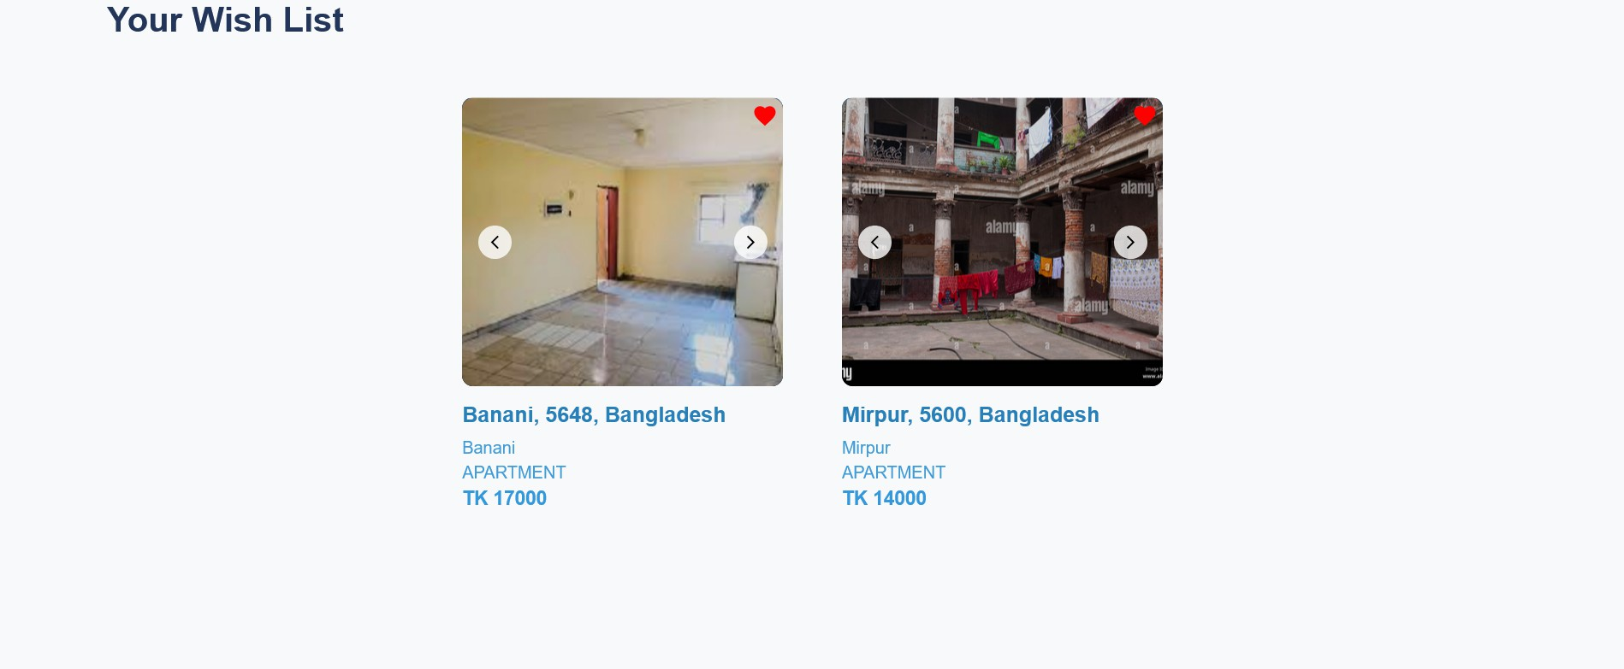
Fig 51: User’s wishlist page

Notifications:
Landlords receive email and pop-up notifications whenever a renter schedules a visit to one of their properties, helping them manage viewings efficiently. They also get notifications when a renter adds their property to a wishlist. These notifications ensure landlords stay updated and can respond promptly to renter interest and actions. Users can check the list of notifications by clicking on the bell icon on the navigation bar.
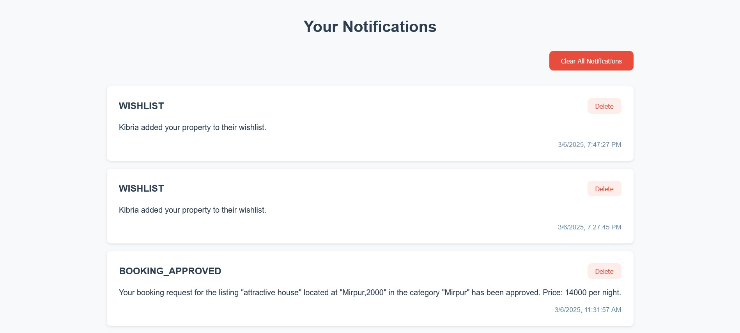
Fig 52: Notification page

Acknowledgement:
- https://www.openstreetmap.org/
- https://socket.io/
- https://www.kaggle.com/datasets/taeefnajib/house-rent-in-dhaka-city

